|  |
| --- |
| MagiZ GamES |
| Survivor |
| **Simple 3D Game** |
| Version 1  All work Copyright © 2012 by MAGIZ Games.  All rights reserved. |
| **[Rui Yang]** |
|  |

|  |
| --- |
| May 16th 2012 |

**Table of Contents**

Content

Version History 3

Game Design 4

Game Overview 4

Game Play Mechanics 4

Camera 4

Controls 4

Interface Sketch 5

Screen Descriptions 6

Game World 6

Characters 7

Enemies 7

Scoring 7

Sound Index 7

Art / Multimedia Index 8

**GitHub : https://github.com/pegasus57/GameAssignment3**

# Version History

Version1: Create the Main scene and add player camera

# Game Design

## Game Overview

*As a player, you are a Survivor of a nuclear explosion, u need to get materials and foods to survive. The more materials and foods you collect, the more score you will get.*

*Also you will meet many monsters which are created by the nuclear explosion.*

## Game Play Mechanics

*You may have 5 lives, and if you touch an enemy, the number lives will minus 1. If it becomes 0, game will over.*

## Camera

*3D FPS*

## Controls

*WASD and Space of User’s Keyboard to control movement*

*Mouse to control camera*

## Interface Sketch

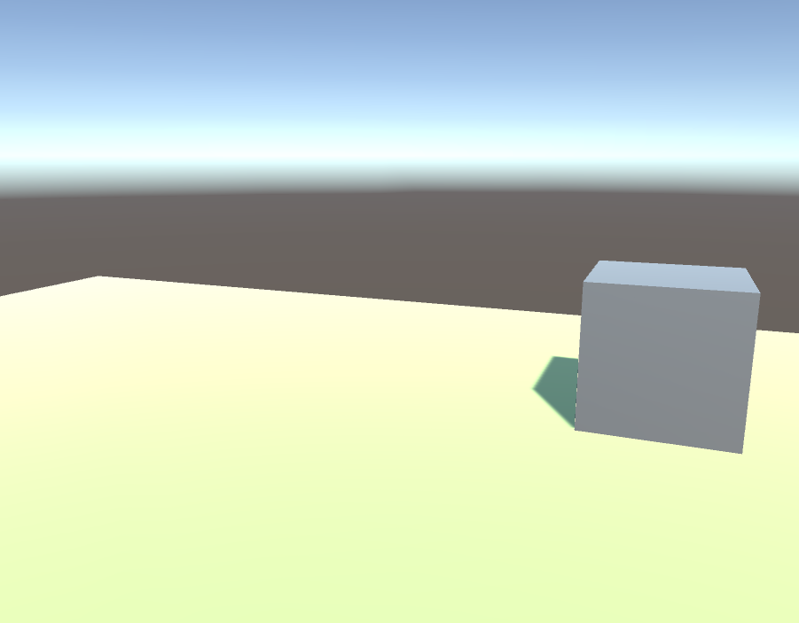

*Stand on the top pf a cube:*



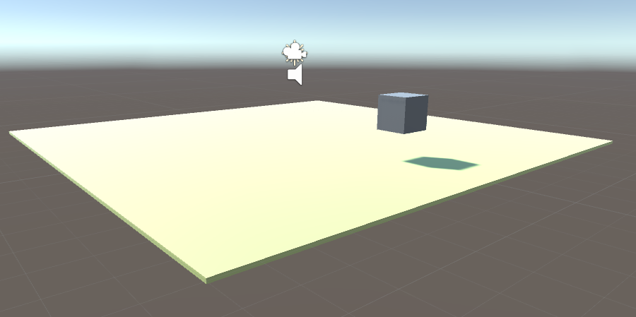

## Screen Descriptions

**When User is playing, there is a lives label on the left corner of top to show user how many lives left,**

**And there is a score board on the right corner of top to show user how much score they have got.**

## Game World

*As a player, you are a Survivor of a nuclear explosion, u need to get materials and foods to survive. The more materials and foods you collect, the more score you will get.*

*Also you will meet many monsters which are created by the nuclear explosion.*

## Characters

## Enemies

## Scoring

Score goes up by collect foods and materials and kill enemies

## Sound Index

Pick up: pick up sound

Hit enemy: hit sound1

Be Hit: hit sound2

Game music: To Zanarkand

## Art / Multimedia Index

Some of those assets may will be used

